Return Distribution Plotting in Python
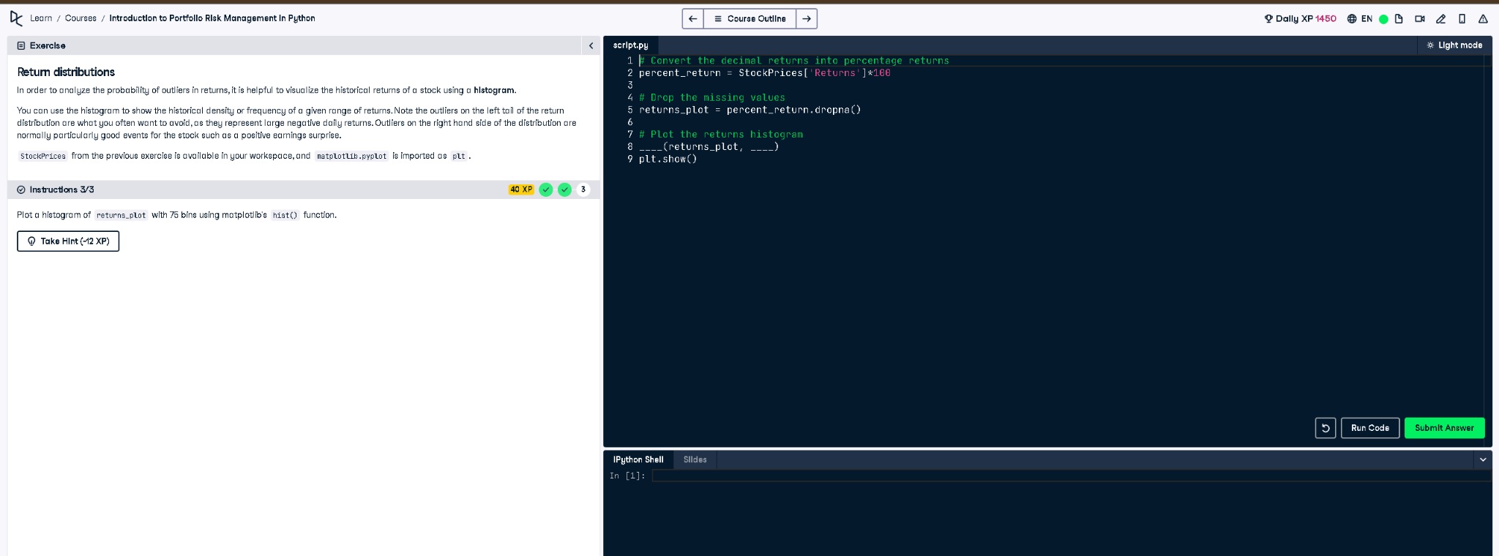

Full Python Code:
# Convert the decimal returns into percentage returns
percent_return = StockPrices['Returns'] * 100
# Drop the missing values
returns_plot = percent_return.dropna()
# Plot the returns histogram
plt.hist(returns_plot, bins=75)
plt.show()

Simple Explanation:
This code first converts stock return values from decimal to percentages by multiplying by 100. Then it removes missing values using dropna(). Finally, it plots a histogram of the cleaned percentage returns using 75 bins with matplotlib to visualize the return distribution.

